How to add Additional authorise for AA Loan/Deposits creation

**Table of Contents**

1. How to Title 4

2. Detailed steps 4

3. Meta Data Track 9

Document History

|  |  |  |
| --- | --- | --- |
| Author | Version | Date |
| Surendar Babu N | 1.0 | 10-02-2022 |

Comments:

|  |
| --- |
| Reviewed by Achuth Rao S |
|  |
|  |

# How to Title

# How to add additional authoriser for AA loan/deposits creation

# Detailed steps

**2.1 OBJECTIVE:**

# How to add additional authoriser for AA loan/deposits creation

**2.2 DESCRITPTION:**

# How to add additional authoriser for AA loan/deposits creation

* If the loan amount Greater than equals 500,000 then override class AAL user needs to be approved the loan creation.

Other user cannot be approved the transaction, can only input the transaction.

* If the user who has approval for AAL override class can input the loan arrangement with more than 500,000 loan amounts , after that any user can approve/authorise the loan creation. Because the AAL user is inputted and its approved the AAL override by input itself.

**2.3 PROCEDURE:**  
Please find the below configuration basic and product level changes to achieve the requirement

**OVERRIDE CLASS DETAILS:**

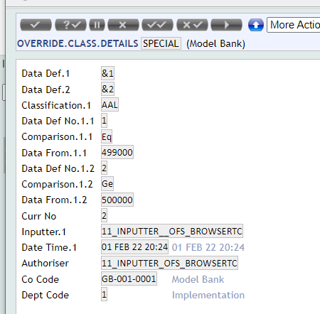

**Term amount condition:**

Set Override to be populate if loan amount more than 499,000

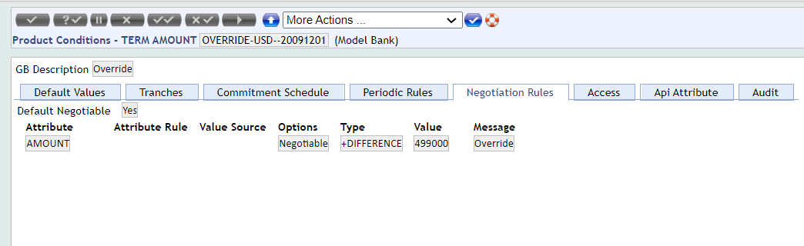

**OVERRIDE:**

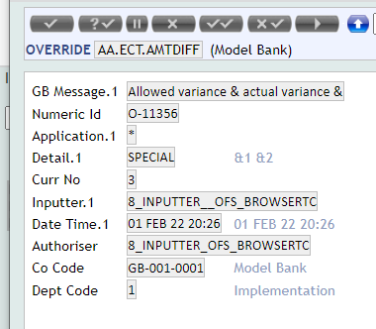

USER: AUTHORISER

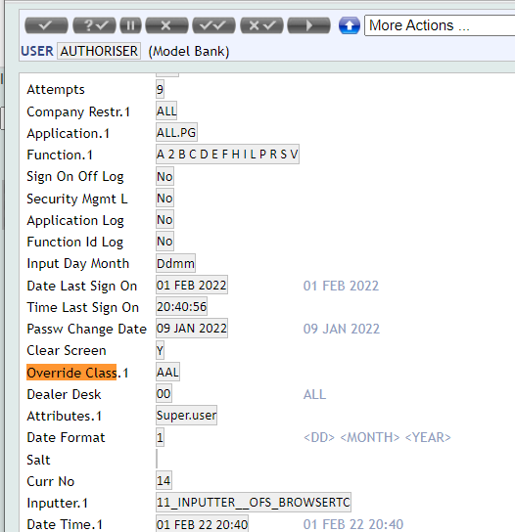

USER: INPUTTER

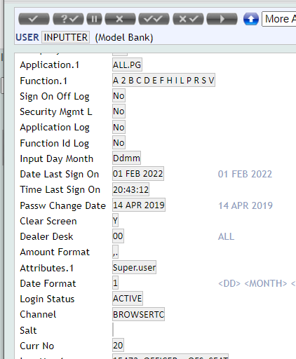

Loan created with amount more than 500,00 using INPUTTER

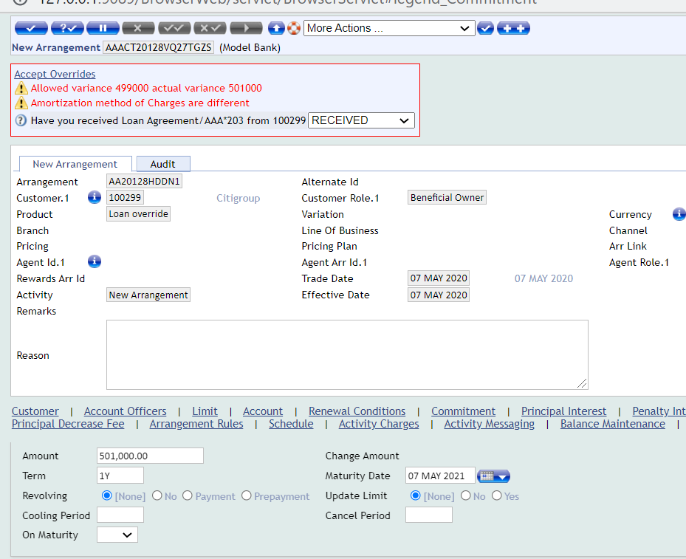

Only user who has access for override class AAL can approve the above loan. If other user tried for approval then it cannot be approved as below

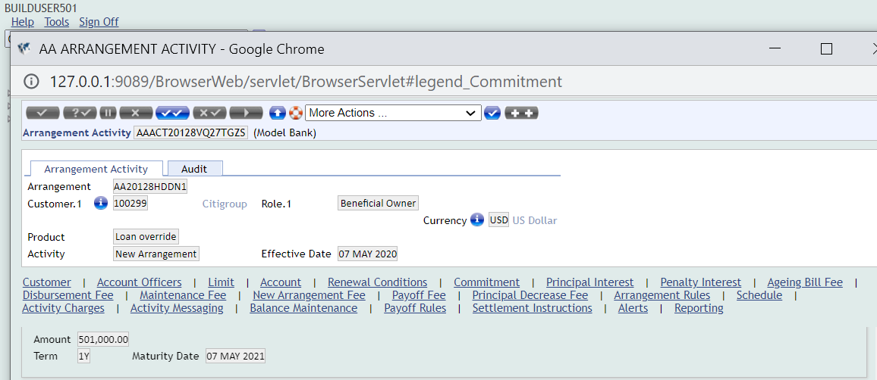

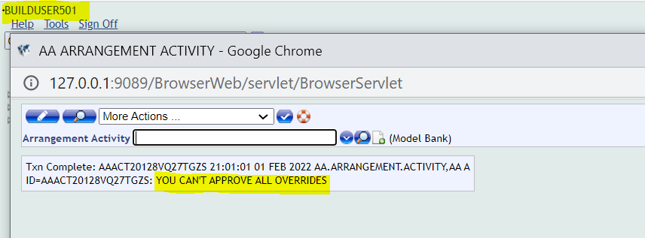

Still unapproved

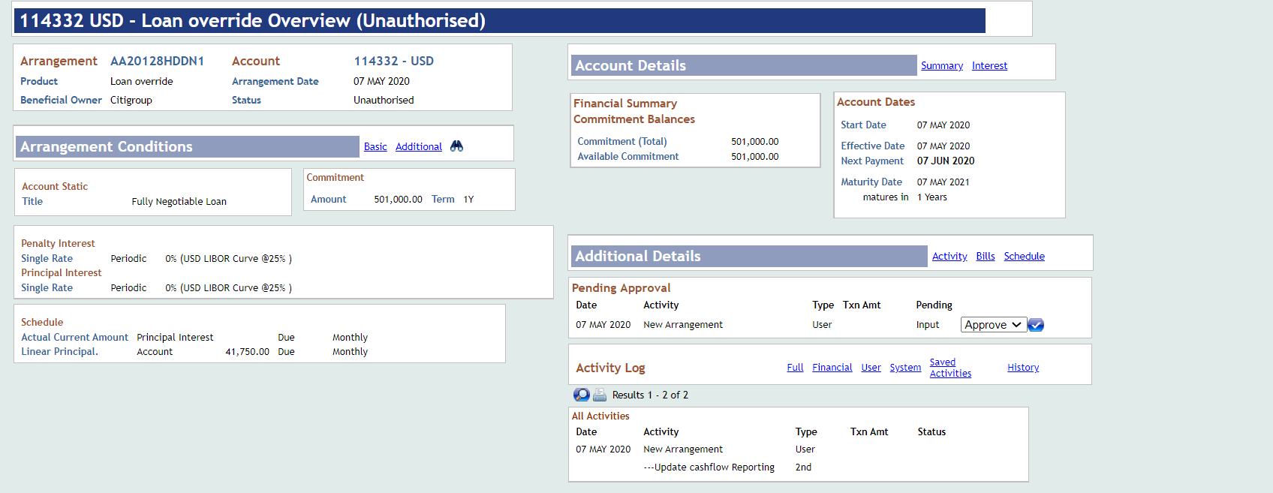

But if we approve by AUTHORISER who has AAL override class approval

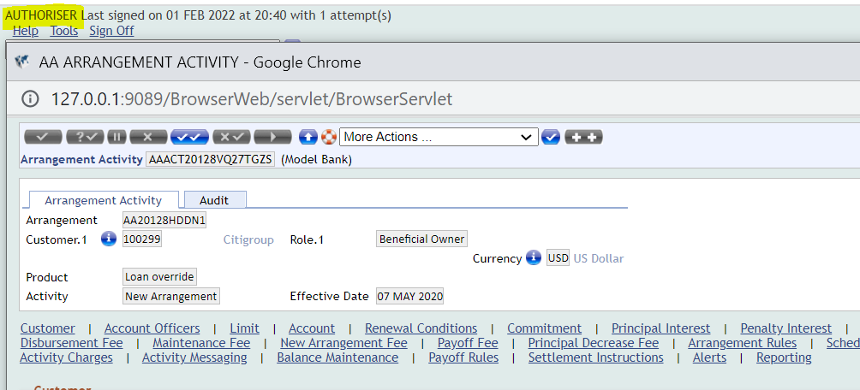

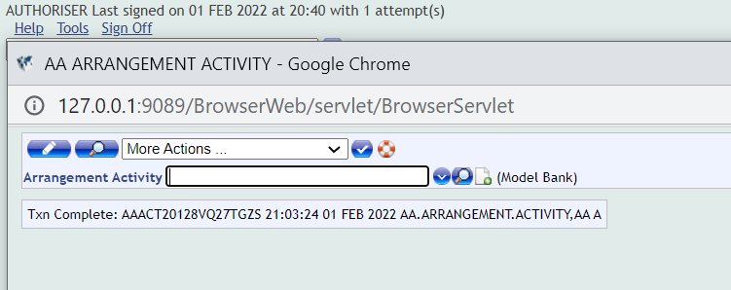

Its Approved

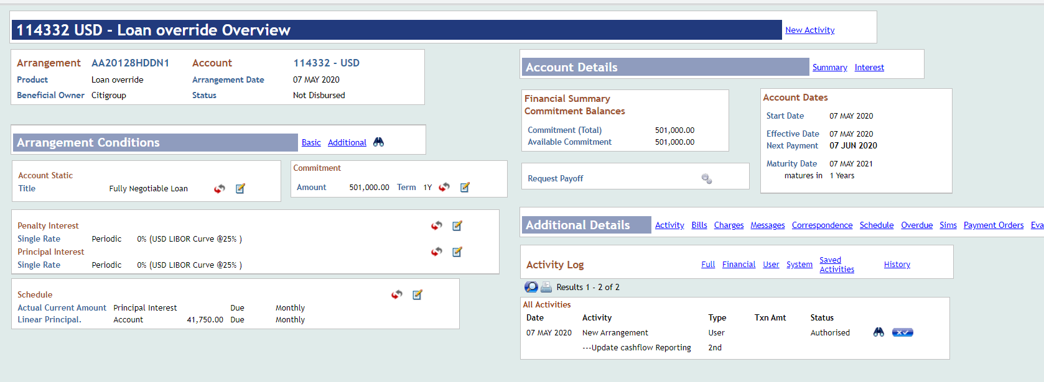

Loan created with amount LESS than 499,00 using INPUTTER

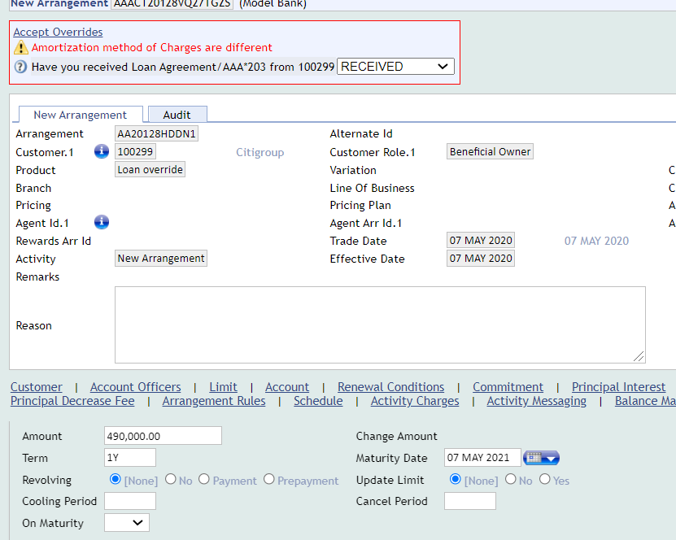

This loan can be approved by any user.

|  |  |  |  |
| --- | --- | --- | --- |
| Meta Data Track | | | |
| **Description of document \*** | How to add additional authoriser for AA loan/deposits creation | | |
| **Product \*** | AA | | |
| **From T24 Release \*** | R13 | | |
| **To T24 Release \***  If the functionality is relevant till R9, choose the value ‘**Current**’ | -Current | | |
| Content Classification | | | |
| **Bank Unit** * | None | | |
| **TAG 1** *(keyword) | Override class for AA | | Enter relevant tag, if not found in the drop-down list. |
| **TAG 2**(keyword) | AA Override definition | | Enter relevant tag, if not found in the drop-down list. |
| **TAG 3**(keyword) | Additional authorizer for AA | | Enter relevant tag, if not found in the drop-down list. |
| Document Administrative Details | | | |
| **Owner:** Surendar Babu N | | **Email ID:** surendarbabun@temenos.com | |
| **Approver:** Achuth Rao S | | **Email ID:** achuth@temenos.com | |
| **Expiry Date:** NA | | **JIRA Reference:**  TSR-206644 | |

# Meta Data Track