**Infinity Code Base - Offline Build**

**Objective:**

In this Article explained the steps to build the Infinity Codebase offline without connecting to Temenos VPN and Temenos Nexus Repository.

This Article explains for Infinity 202102 version, the same procedure you can follow for the next version as well.

**Pre-Requisites:**

1. Maven (apache-maven-3.6.3 and later versions) by having path variable to **\bin** folder.
2. Java1.8 (Or later versions) by having path variable to jdk1.8 **\bin** folder.

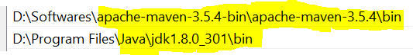

**Step-1)** Open Parent **pom.xml** (DbpLocalServices_Src_v202102\localservices\Fabric\java> pom.xml file) under <repositories> tag find the below <repository> subtag.

.

<repository>

<id>dbx</id>

<name>dbx releases</name>

<url>

http://maven.konylabs.net:8081/nexus/content/repositories/dbx

</url>

<releases>

<enabled>true</enabled>

</releases>

</repository>

Replace with the below offline <repository> Tag.

<repositories>

<repository>

<id>dbx</id>

<name>dbx releases</name>

<url>

<!-- http://maven.konylabs.net:8081/nexus/content/repositories/dbx -->

https://quantum-maven.temenosgroup.com/content/repositories/dbx/

</url>

<releases>

<enabled>false</enabled>

</releases>

</repository>

<repository>

<id>project-local-repo</id>

<name>Local repo</name>

<url>file://${project.basedir}/../../../maven-local-repo</url>

</repository>

</repositories>

**Step-2)** Copy and paste the "infinity-API-commons.jar" into the below path with a valid folder structure *(the artifacts shared by the temenos distribution team)*

DbpLocalServices_Src_v202102\localservices\maven-local-repo >

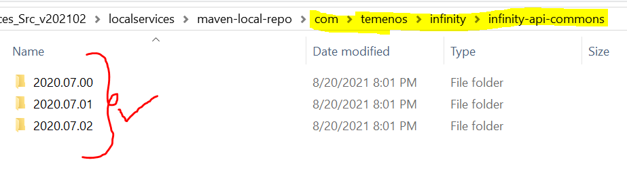

**Note**: For Example, here mentioned 2020.07, So as per the cusotmers current version, please ensure that the directories have the relevant version name of the jar name.

**Step-3)** Go to the root folder and build the code with the below mvn build.

**Cmd/path to java folder > mvn clean install**



**END**